
Dashboard Design

Date | 21 August 2026
Team ID | --
Project Name | India's Agricultural Crop Production Analysis (1997–2021)
Maximum Marks | 5 Marks

Creating an effective dashboard involves thoughtful design to ensure that the presented information is clear, relevant, and easily understandable for the intended audience. Here are some key principles and best practices for dashboard design
Activity 1: Interactive and visually appealing dashboards
The dashboard presents a comprehensive analysis of India's agricultural crop production for the period 1997–2021. It combines multiple visualizations, summary indicators, filters, and an interactive map to make agricultural data easy to understand and compare.
The following dashboard design principles are applied:

- Clear and Intuitive Layout:
The dashboard is arranged into different sections for production, cultivated area, yield, seasons, crops, and states. Important information is displayed in a structured and easy-to-read format.
- Use Appropriate Visualizations:
Different visualizations are used according to the data, including pie chart, bar charts, horizontal bar chart, line chart, map, donut chart, and summary cards.
- Colour and Theming:
Different colours are used to distinguish between crops, seasons, states, and years. Consistent formatting and chart titles improve the readability of the dashboard.
- Interactive Filters and Slicers:
The dashboard provides interactive filters for Season, Year, State, Crop, Production Units, Production, and Measure Names. These filters allow users to analyze specific parts of the agricultural dataset.
- Drill-Down Capabilities:
The dashboard allows users to examine agricultural information at different levels, including year-wise production, state-wise production, crop-wise cultivated area, season-wise production, and yield trends.
- Responsive Design:
The visualizations are organized within a single dashboard so that users can view major agricultural indicators and comparisons together.
- Custom Visuals and Icons:
Customized titles, labels, summary cards, legends, and interactive controls are used to make the dashboard informative and user-friendly.
- Use of Infographics:
Infographics are used in the dashboard to present complex agricultural data in a simple, clear, and visually attractive manner. Different charts and visual elements are used to make comparison and analysis easier.
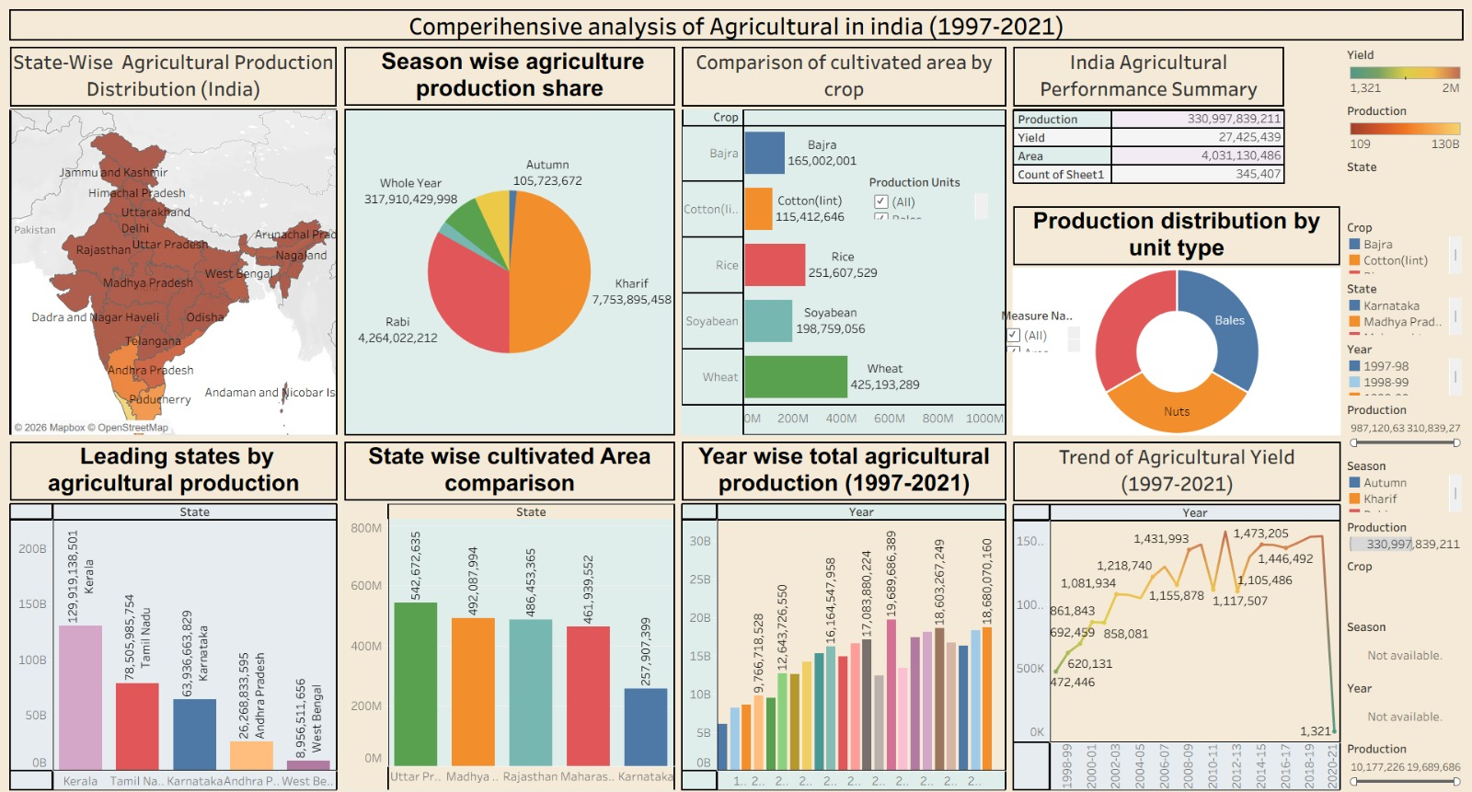

Note: Highlight the major outcomes in form of bullet points:
- Overall Agricultural Performance: The dashboard reports total agricultural production of 330,997,839,211, with a total yield of 27,425,439 and cultivated area of 4,031,130,486. These figures provide an overall view of India’s agricultural performance during 1997–2021.

- Leading State in Production: Kerala has the highest agricultural production among the selected leading states, with 129,919,138,501, followed by Tamil Nadu (78,505,985,754) and Karnataka (63,936,663,829).

- Crop-wise Cultivated Area: Wheat has the largest cultivated area among the selected crops, with 425,193,289, followed by Rice (251,607,529) and Soyabean (198,759,056). This highlights the comparatively larger cultivated area associated with wheat.

- Season-wise Production: The season-wise visualization shows that Kharif contributes the largest share of production at 7,753,895,458, followed by Rabi with 4,264,022,212. This indicates a major contribution from Kharif-season agriculture.
- Agricultural Yield Trend: The yield trend shows considerable variation over the study period. The highest displayed yield is 1,577,453 in 2011–12, while the chart shows a sharp decline to 1,321 in 2020–21.

- Year-wise Production Trend: The year-wise chart shows an overall increase in agricultural production across much of the period, with 2011–12 recording 19,689,686,389 and 2020–21 showing 18,680,070,160.

- Production by Unit Type: The infographic compares agricultural production according to Bales, Nuts, and Tonnes, making it easier to understand how production is distributed among different production units.

- Interactive Analysis: The dashboard uses filters such as Year, State, Crop, Season, Production Units, and Measure Names, allowing users to explore agricultural production, area, and yield according to different categories.

Activity 2
Publish Dashboard on Tableau Public and Paste the Dashboard Public link below:

https://public.tableau.com/app/profile/vishnu.kumari/viz/Book1_17874992907710/Dashboard1?publish=yes

